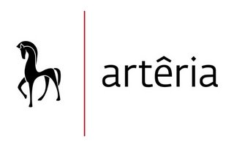

MELISSA BEAULIEU

EDUCATION
2003 B.A. – Visual Arts, UQTR, Trois-Rivières
2002 D.C.S. – Visual Arts, Cégep de Trois-Rivières, Trois-Rivières
1999 D.C.S. – Graphic Design, Cégep du Vieux-Montréal, Montreal

SOLO EXHIBITIONS
2022 Shadow, ARTWRK/ Gallery, Canada

2012 Life Happens, Galerie Luz, Montreal, Canada

COLLECTIVES EXHIBITIONS
2022 THE HOLY ART THESIS Art Show, The Holy Art Gallery, London, UK

2021 Marbella–International Art Festival (FIAM), Van Gogh Gallery, Marbella, Spain
2021 Online Edition, The Other Art Fair, Saatchi Art Online Gallery

2014 ArtCrasher, Venice Arts Gallery, Los Angeles, US

2012 Emerging Female Artists Exhibition, The Gerry Thomas Gallery, Calgary, Canada

2010 Willow Design, Saskatoon, Canada
The Mptresart Gallery, South Durham, Canada

2009 FIMA Festival International Montréal en Arts, Montreal, Canada

